Cherryl’s Class
TV Guide

Time | RTE1 | BBC1
5.00 | Dennis the Menace and Gnasher | The Simpsons
5.30 | A Place in the Sun | Sabrina the Teenage Witch
6.00 | News and Weather | BBC News
7.00 | Emmerdale | Coast
7.30 | Coronation Street | Eastenders
8.00 | The X Factor | Strictly Come Dancing
9.00 | News and Weather
9.30 | Film- James Bond, Spectre
10.00 |  | BBC News
11.00

Which show?

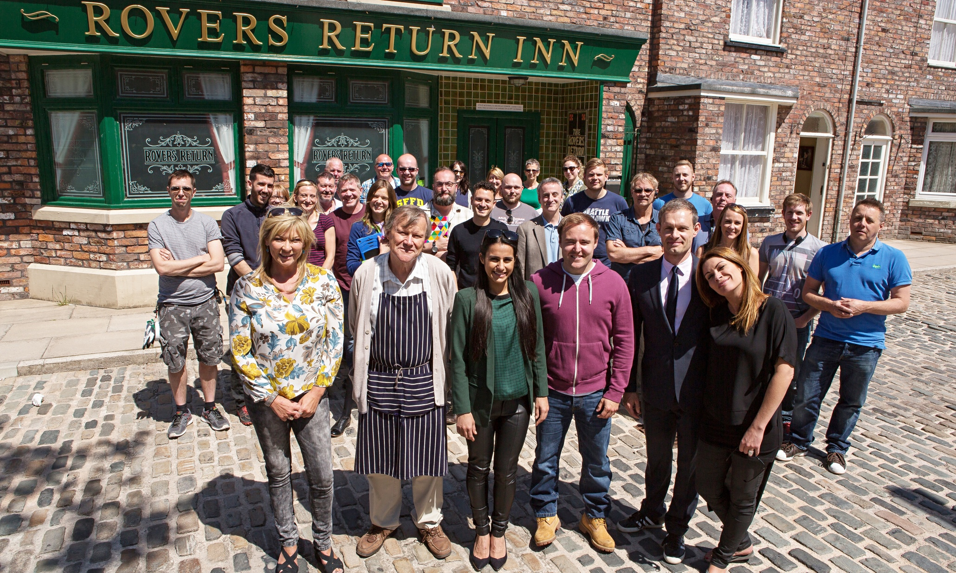

__________________________ ____________________________

__________________________ ____________________________

__________________________ ____________________________

__________________________ ____________________________

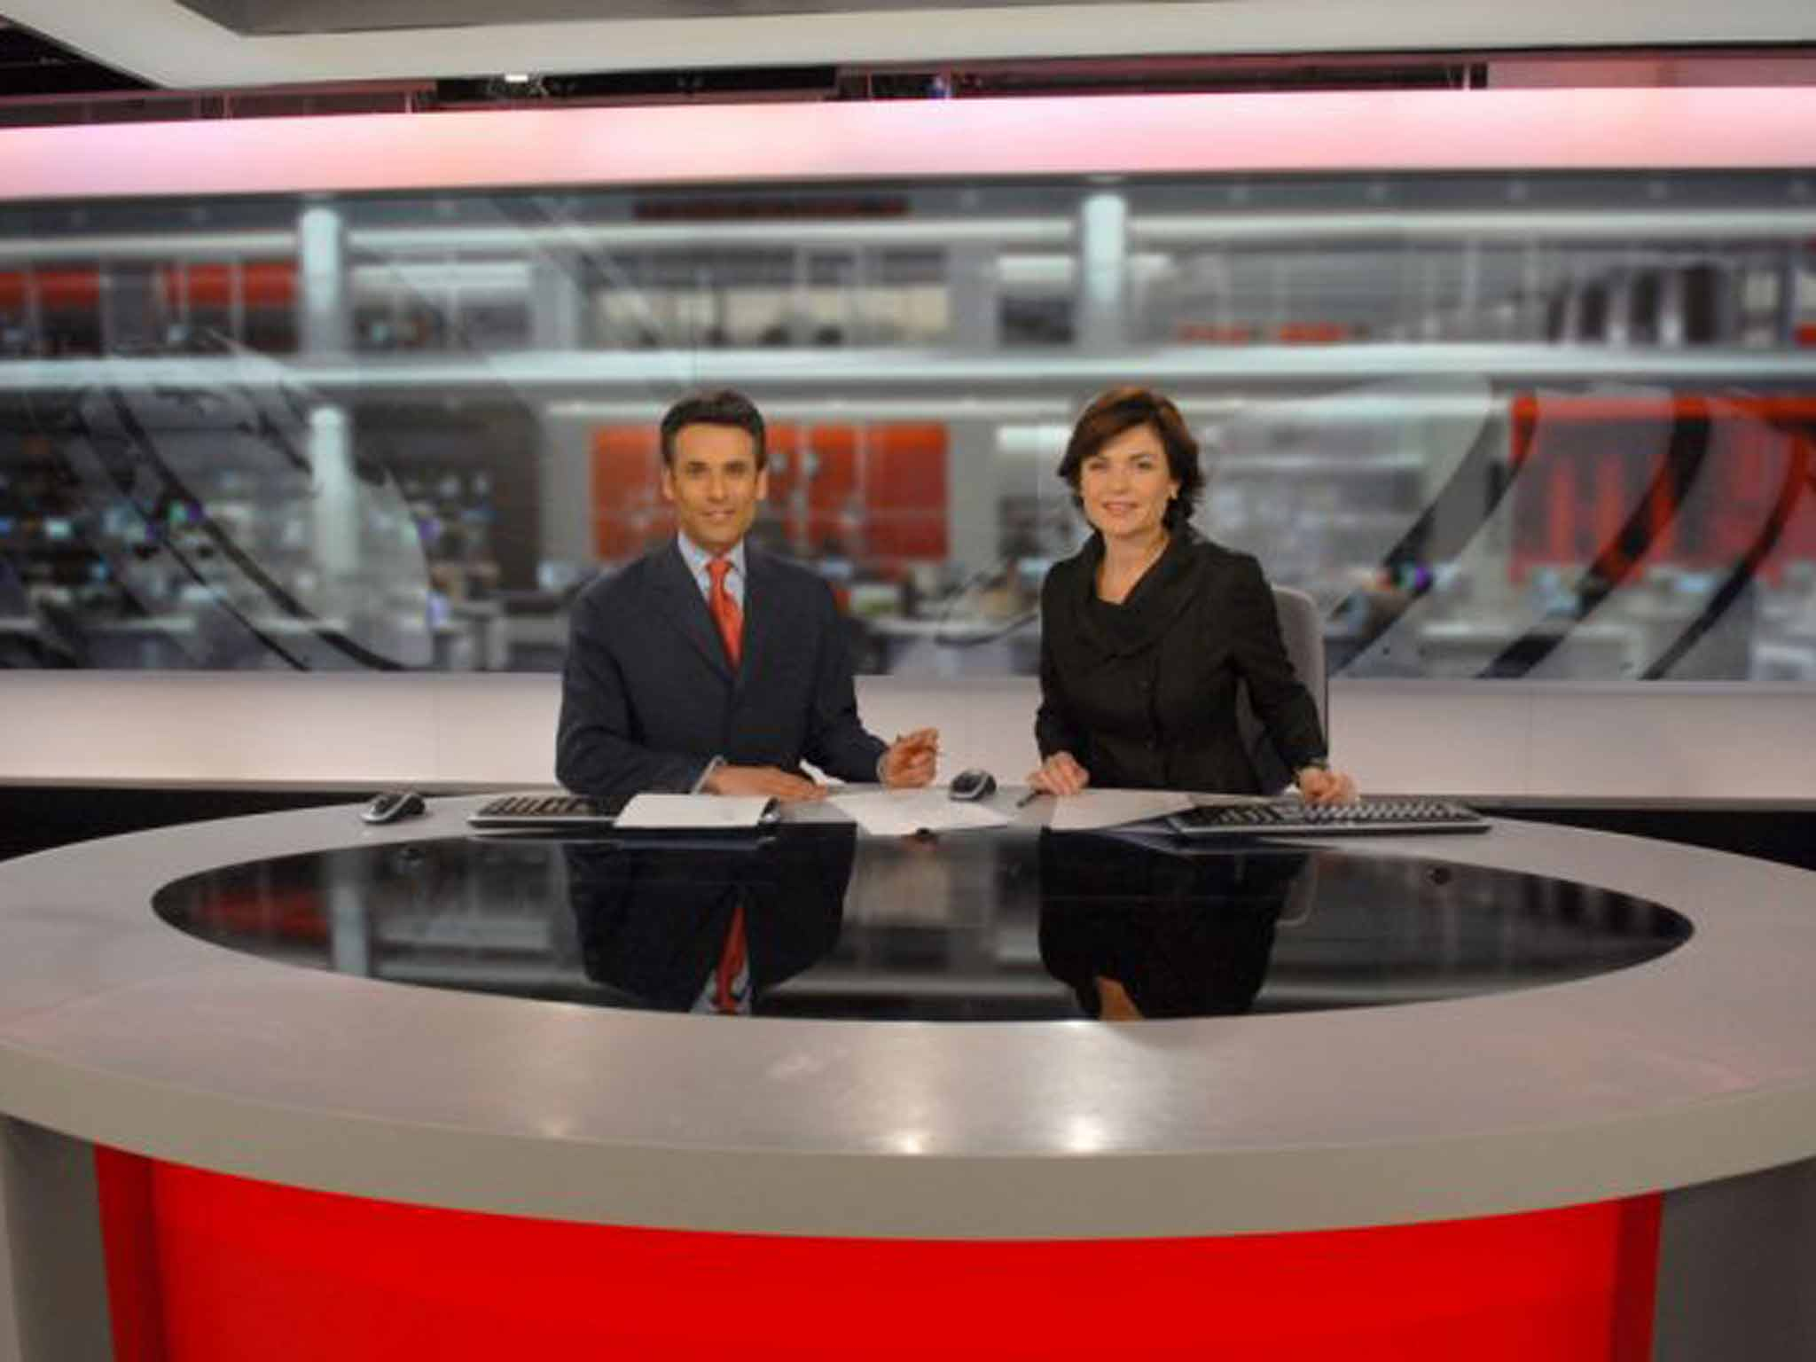

__________________________ ____________________________

__________________________ ____________________________

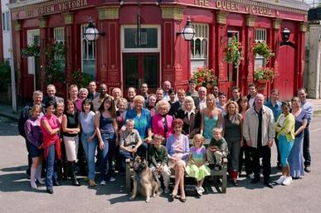

__________________________ ____________________________

__________________________ ____________________________
Cherryl’s Class
TV Guide
Questions;

- What programme starts at 9.00?
_________________________________________________________________
- What programme starts at 9.30?
_________________________________________________________________
- What programmes finish at 8.00?
_________________________________________________________________
- What programme start at 5.00?
_________________________________________________________________
- What channel is Coast on?
_________________________________________________________________
- What channel is The X-Factor on?
_________________________________________________________________

Cherryl’s Class
TV Guide
Questions;

- When is the news on both RTE and BBC at the same time?
__________________________________________________________________
- What is the film on RTE called?
_________________________________________________________________
- What is your favourite programme?
_________________________________________________________________
- When is it on?
_________________________________________________________________
- What channel is it on?
_________________________________________________________________
- What programme do you not like?

Cherryl’s Class
TV Guide

What programmes would you chose to watch? Start at 5.00 and plan what you would watch for the evening.

Time | Name of Programme | Channel

Cherryl’s Class
TV Guide
Questions;

- What programmes start at 5.30?
_________________________________________________________________
- What programmes are ‘soaps’?
_________________________________________________________________
- What is your favourite soap (if you watch them)?
_________________________________________________________________
- What do you think Coast is about?
_________________________________________________________________
- What do you think ‘A Place in the Sun’ is about?
_________________________________________________________________
- What cartoons are on?
_________________________________________________________________

Cherryl’s Class
TV Guide

Time | RTE1 | How long is the programme?
5.00 | Dennis the Menace and Gnasher | 30 minutes
5.30 | A Place in the Sun
6.00 | News and Weather
7.00 | Emmerdale
7.30 | Coronation Street
8.00 | The X Factor
9.00 | News and Weather
9.30 | Film- James Bond, Spectre
10.00
11.00

Cherryl’s Class
TV Guide

Time | BBC1 | How long is the programme?
5.00 | The Simpsons | 30 minutes
5.30 | Sabrina the Teenage Witch
6.00 | BBC News
7.00 | Coast
7.30 | Eastenders
8.00 | Strictly Come Dancing
9.00
9.30
10.00 | BBC News
11.00

